Resume Score vs. Human Review: Which is the Best Fit?
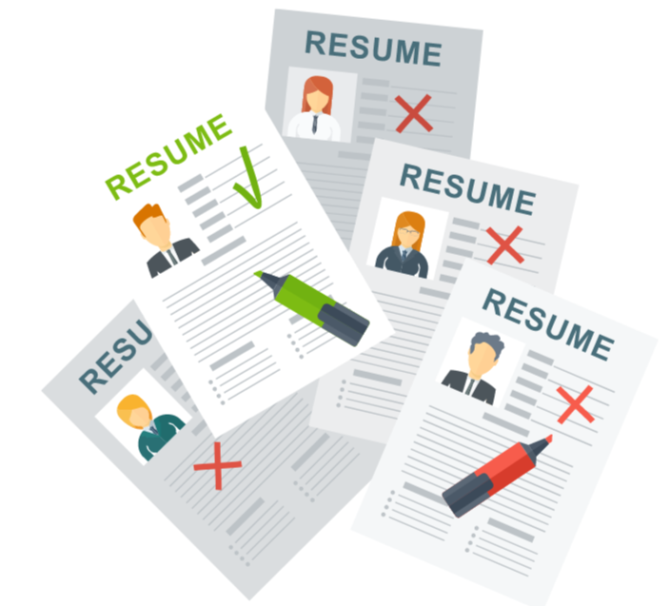

The modern job market is filled with job seekers who find it a challenge to navigate through both automated resume screening systems & human reviewers. On one hand, the automated resume scores reflect speed & efficiency while the human reviewers demonstrate contextual understanding.
The choice is difficult to make when it comes to choosing which one is better. This blog will help you to take a closer look at how the Applicant Tracking Systems & Human Recruiter’s influence your job application & how you can navigate both effectively.

Applicant Tracking Systems
- Keyword Relevance: ATS systems scan resumes for specific keywords related to the job description. Resumes that closely match these keywords are more likely to pass through the initial screening & the rest end up getting rejected. To secure your spot through the initial screening round, tailor your resume with relevant keywords from the job listing. You can have access to these keywords from the Job Description provided by the recruiters.
- Formatting: ATS can struggle with complex formats, images & unusual fonts. Because of this, even though your resume is top-notch & contains all the details required, it may end up getting rejected. So, try sticking to a simple, clean format to ensure your resume is easily read by the system.
- Quantifiable Metrics: Automated systems often look for quantifiable achievements. Make sure to include specific numbers & data to highlight your accomplishments, as these stand out not just to ATS but also to the human reviewers.
- Speed: Automated systems, like Applicant Tracking Systems (ATS), quickly process large volumes of resumes, allowing for faster initial screenings. Make sure your resume is simple & short reflecting all the necessary details.
- Consistency: Automated scores apply the same criteria across all resumes, which can reduce potential biases in the initial filtering process. Consistency is usually the most important feature looked for when it comes to the Applicant Tracking Systems.

Human Reviewers
- Context & Relevance: Humans review resumes with an eye for context & relevance beyond keywords. They assess your overall experience, career trajectory & how well you fit into the company culture. ATS cannot do this.
- Soft Skills & Personality: Unlike ATS, human reviewers can gauge soft skills, personality traits & other nuances that may not be captured by automated systems. To enable recruiter’s better, make sure your resume & cover letter reflect your unique attributes & interpersonal skills.
- Custom Tailoring: Human reviewers appreciate tailored resumes to the specific role & company. Personalized content shows genuine interest & effort, setting you apart from generic applications.
- Insight & Judgment: Human Recruiter’s assess aspects like cultural fit, leadership qualities & the overall presentation of the resume, which are harder for automated systems to evaluate. ATS mostly focuses on keywords.
- Adaptability: Human reviewers can appreciate creative & non-traditional career paths, valuing unique experiences that may not fit neatly into keyword-based algorithms.

Preparing for both - Things to keep in Mind!
- Optimize for ATS: Incorporate relevant keywords & phrases from the job description into your resume. This can improve your chances of passing through automated filters & getting noticed.
- Craft a Strong Resume: Focus on creating a well-organized, clear & compelling resume. Highlight your achievements & skills in a way that stands out both to algorithms & human reviewers.
- Prepare for Human Interaction: Emphasize unique accomplishments & the impact of your work on your resume. This will appeal to human reviewers who look beyond keywords to understand the full scope of your qualifications.
- Test Your Resume: Use resume-checking tools that simulate ATS behavior to ensure your resume is optimized for automated systems. This can help you identify & address potential issues before submitting your application. PaintMinds is one such tool that comes in handy when looking to check your resume review scores. Backed by a team of experts, it brings you closer to creating a high-impact resume.

Conclusion
To maximize your chances of career success, it is essential to tailor your resume to meet the needs of both automated systems & human reviewers. Balancing these elements will not only improve your visibility but also ensure that your unique qualifications & experiences shine through in every stage of the hiring process.

Keywords: Resume Score | Resume Review | career success | tailored resumes | Strong
Focus: Resume Score
Meta Tag: Resume Score vs. Human Review: How Automated Scores Impact Your Job
Meta Description: Maximize the chances of your career success by tailoring your resume to the needs of ATS & Human Recruiter’s. Learn How.
Title Tag: Resume Score vs. Human Review: Impact on Your Job Search | PaintMinds

